What is our Project?

Something we are interested in and with 20 parts or more (but 22 or under is optimal).

1. Ultra budget VR rig, using RFID chips.
2. Bicycle
   1. Normal, simple 20 parts and easily repairable.
3. **Candles Making Machine?**
   1. <https://www.amazon.com/Byoowndiy-Electric-Temperature-Controller-WMF-01/dp/B09XXM389Q/>
   2. Make it metal inside, fire retardant outside layer for insulation and safety.
4. A fan for a house, a ceiling fan or wall fan.

Candle Making Machine Won

PDR

2023-05-17 is the date of the PDR

Edgar’s Sketch: Wall Mounted Candle Maker

<https://www.tinkercad.com/things/4ZpfnSgwqOI-frantic-luulia/edit?sharecode=S2A3ATSwqdlovOBXc6H9YNf4GPVZWfCdQWAx5xJYl_U>

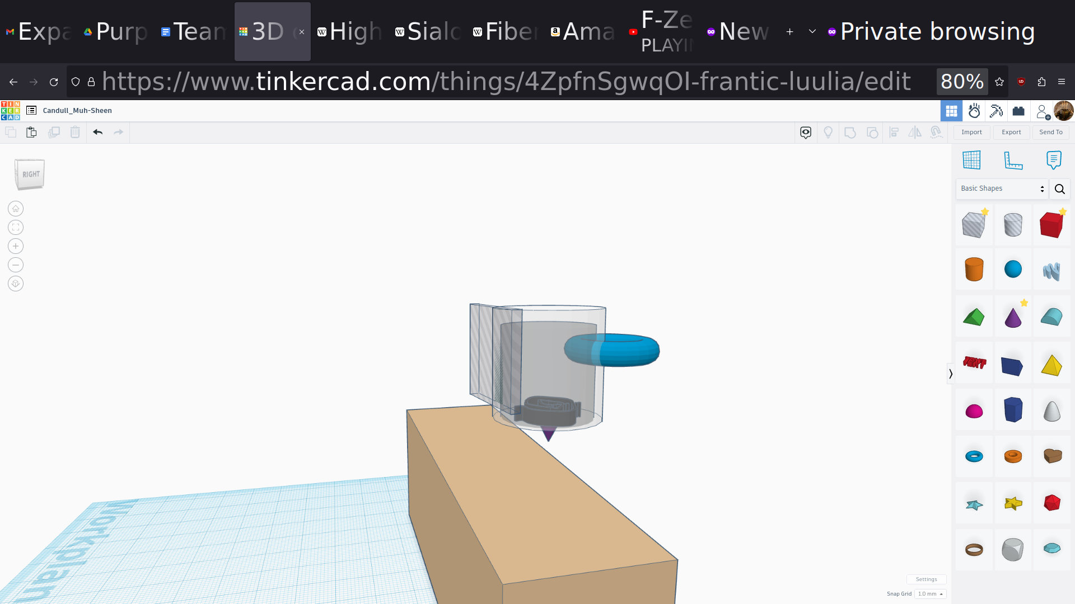

10 Design Requirements?

Inventor Access:

<https://shadow.tech/>

Who is the customer? A parent who loves candles for their home.

Size: 1 Gallon

Cylinder should be **12 inches tall and have an internal diameter of 5 inches**

Old Parts:

1. Internal metal melting pot [Edgar]
2. External insulating pot and lid
3. Hot Nozzle and wax pouring mechanism. [Edgar]
4. Temperature Control [Brenden]
5. Heating Mechanism [Edgar]
6. Heating and Warm Light
7. Power Button
8. Wall Mount Mechanism [Brenden]
9. Handlebar Mechanism [Brenden]
10. Magnetic Stirrer
11. Wick Inserting Mechanism
12. Wick Feeding Mechanism
13. Wick Stabilizing Mechanism
14. Wax detector (using light emitting diode and light sensor)
15. Chamber for scents and color additives
16. Mechanism to feed additives to main wax

Existing Candle Machine

<https://www.youtube.com/watch?v=bEhlvggbwk8>

<https://americancrafts.com/products/we-r-wick-candle-machine-kit>

$120 USD

Cost of the machine plus wax plus wicks must be less than amazon candles every two weeks for 5 years.

<https://www.amazon.com/Yankee-Candle-Studio-Medium-Coconut/dp/B0BLXJ5ZYY/ref=sr_1_2?crid=3EZCL10U2FC7J&keywords=candle&sprefix=candle%2Caps%2C126&sr=8-2>

**Price to Beat: $10/ (2 Weeks) * (5 Years) = $1303.57**

**Cost of wax:**

**Mass of wax: 10 oz/ (2 Weeks) *(5 years) = 1303.57 Oz ~= 81.5 lbs of wax**

Cost of units of wax and wicks is: $25.69/5lbs <https://www.amazon.com/Hearth-Harbor-Natural-Candle-Supplies/dp/B08J1JHH5X/ref=sr_1_2?crid=3NJVF9SNR995O&keywords=soy%2Bwax%2Bfor%2Bcandle%2Bmaking&sprefix=soy%2Bwax%2Caps%2C156&sr=8-2&th=1>

Cost of Material = 81.5 lbs * ($25.69/ 5 lbs) = $418.79

Budget for Machine = Price to Beat - Cost of Material

Budget for Machine $1303.57 - $418.79 = **$884.78**

50 lbs limit based on OSHA requirements for regular lifting by a service technician.

<https://www.osha.gov/laws-regs/standardinterpretations/2013-06-04-0>

**Cleaning Mechanism:** Make hotpot threaded, make insulation counter threaded, make heating element and nozzle threaded, all removable from insulated outside.

<https://www.youtube.com/watch?v=umHb-S4pEnE>

**Wick Installing Mechanism:** Some candles come with stiffer, wooden wicks. This might be easier to mechanical insert and keep still while the wax is setting.

<https://youtu.be/ocTi_xzIpz0?t=286>

Add a **collet** (camera aperture) as the wick holding and cutting mechanism?

Add legs to allow taller and wider molds for their candles/

Legs must support a high safety factor over the weight of the machine and wax

We think the legs should be five inches tall.

**Add heating coil/block!**

Mass of beeswax in a gallon is over 8 lbs

[https://www.wolframalpha.com/input?i=0.96+grams+per+cubic+centimeter+*%281+gallon%29](https://www.wolframalpha.com/input?i=0.96+grams+per+cubic+centimeter+*%281+gallon%29)

Edgar’s 7 Design Requirements:

1. Intended for indoor, home consumers candle making.
2. Able to pour melted wax into any candle mold desired. Should hold a gallon of wax.
3. Insulated to keep a batch of molten wax liquid for up to 4 hours.
4. Outer shell should be safe to touch during operation.
5. Should be powered by AC electricity with a 12 foot power cable.
6. Should have a controlled temperature range for wax between 200 F and 400 F.
7. Should be less than 25 lbs when empty.
8. Should have a thermally insulated, manual control valve.
9. Visual notification for when it is on and when it is hot.
10. Internal metal cooking container and metal hot end nozzle must be chemical inert to most waxes.
11. Must have a simple feed or insert mechanism to optionally insert the wick, done in a second operation.
12. Should be more cost effective per candle than buying an equal volume of store bought candles (in 5 years).

**Brenden’s 7 Design Requirements:**  
1. Outer Insulated Cooler so you don’t accidentally touch the hot metal so easily  
2. Easy to clean   
3. Melting Pot must be resistant to hot temperatures  
4. Should be cost worthy for making the candle itself ( in 5 years)  
5. Melting pot must hold the temperature to melt the wax  
6. Must have a temperature dial to control the temperature  
7. The nozzle must not get clogged easily when pouring the melted wax.

The Hexagon Hive  
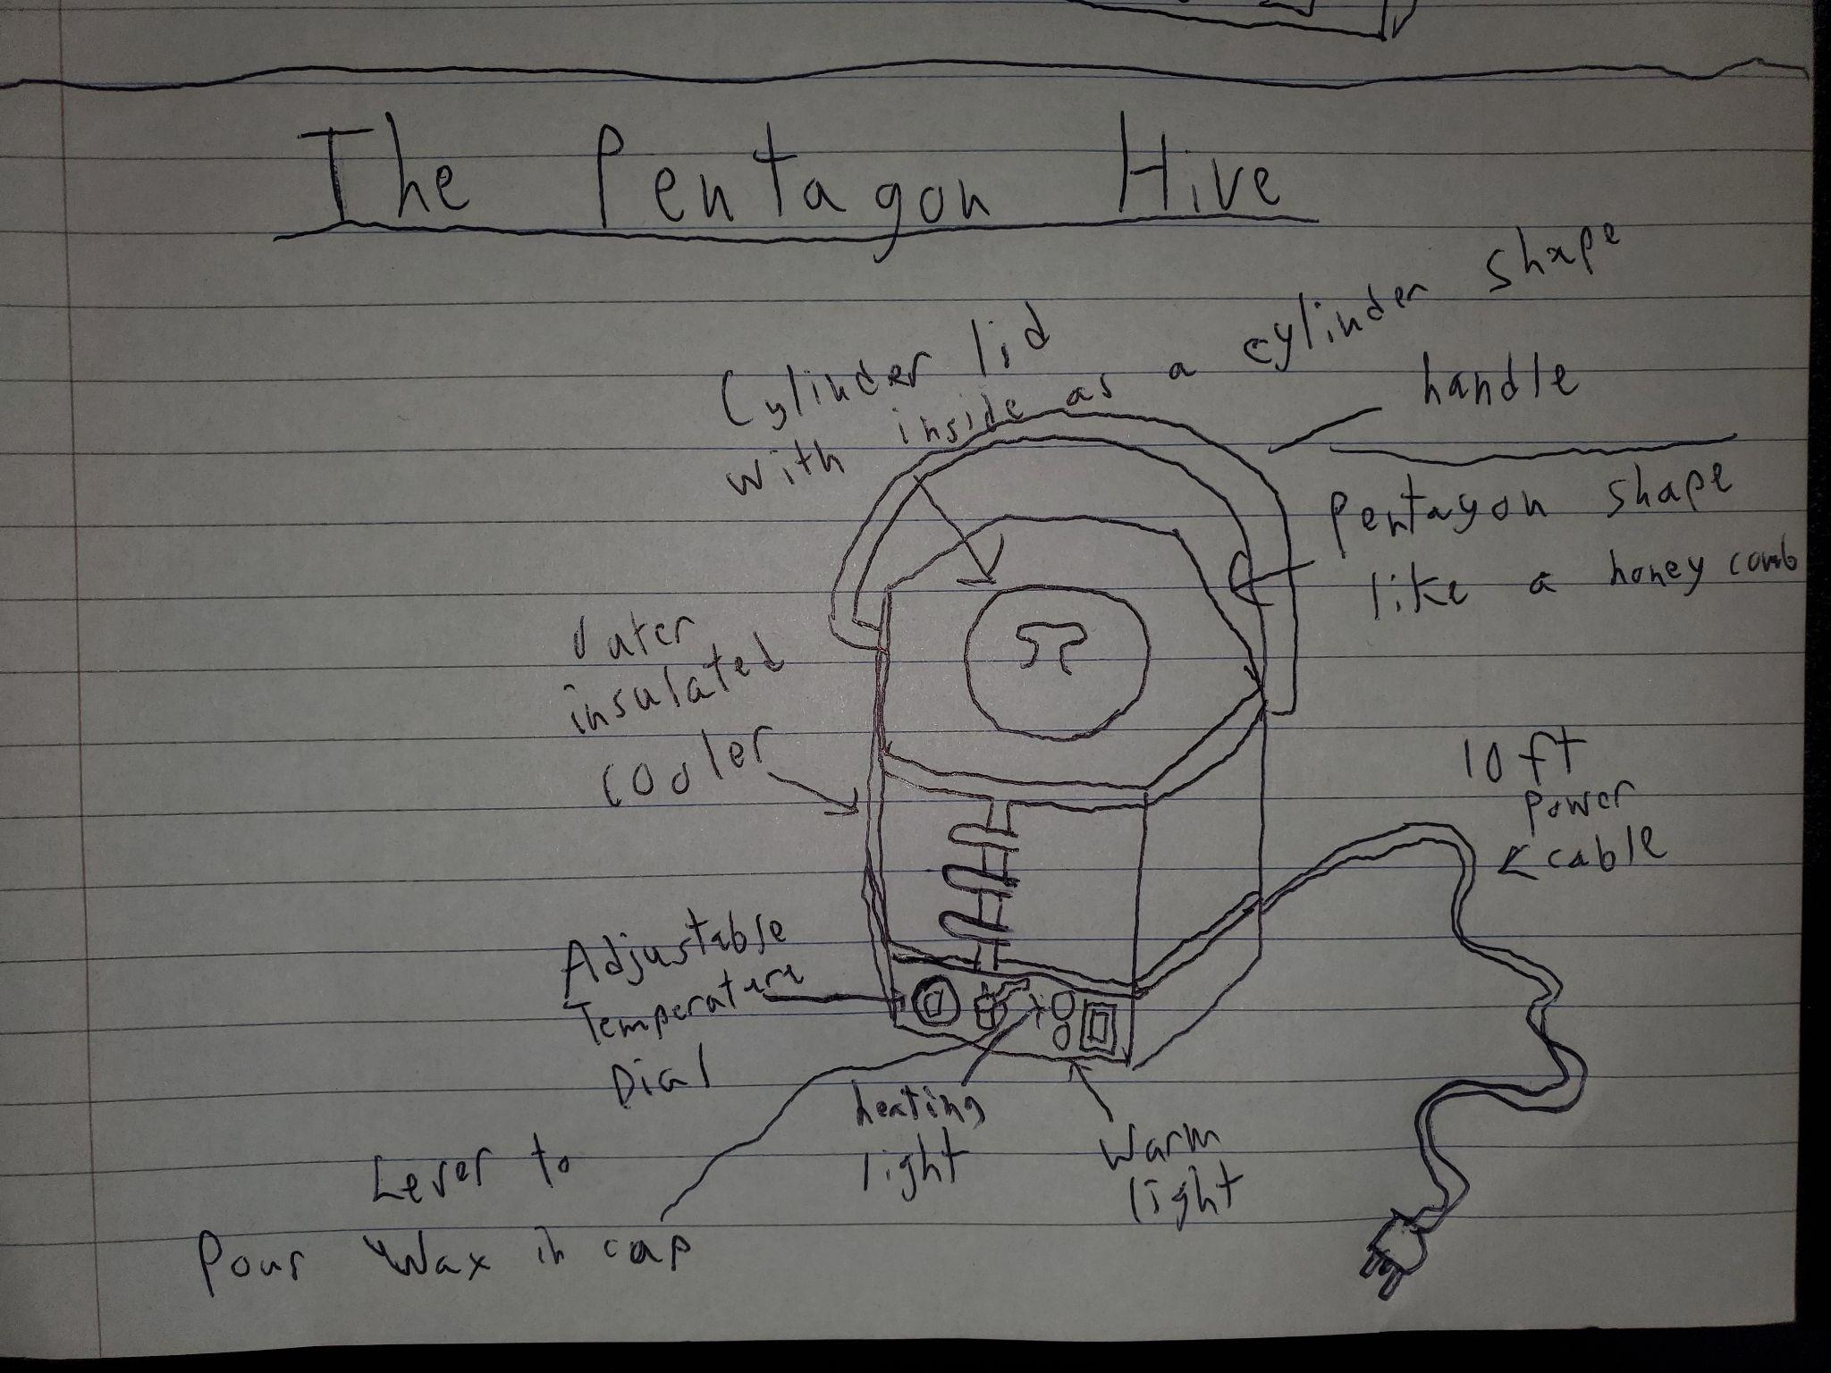

Magnetic Stirrer as a Premium Option

<https://www.youtube.com/watch?v=fzzV75aMM1c>

Winner was Brenden’s design, we will go with a pentagonal, honeycomb motif since beeswax is a premium candle material.

Hexagonal Hive 2023-05-20 Parts List:

1. Internal metal melting pot [Edgar, done
2. External insulating pot and lid [Edgar, done]
3. Hot Nozzle and wax pouring mechanism. [Edgar, done]
4. Temperature Control [Brenden, done]
5. Heating Mechanism [Edgar, Done]
6. Heating and Warm Light [Brenden, done]
7. Power Button [Brenden, done]
8. Handlebar Mechanism [Edgar, done]
9. Magnetic Stirrer [Edgar, still in progress]
10. Three Prong Nema Power Insert (C14) [Brenden, done]
    1. 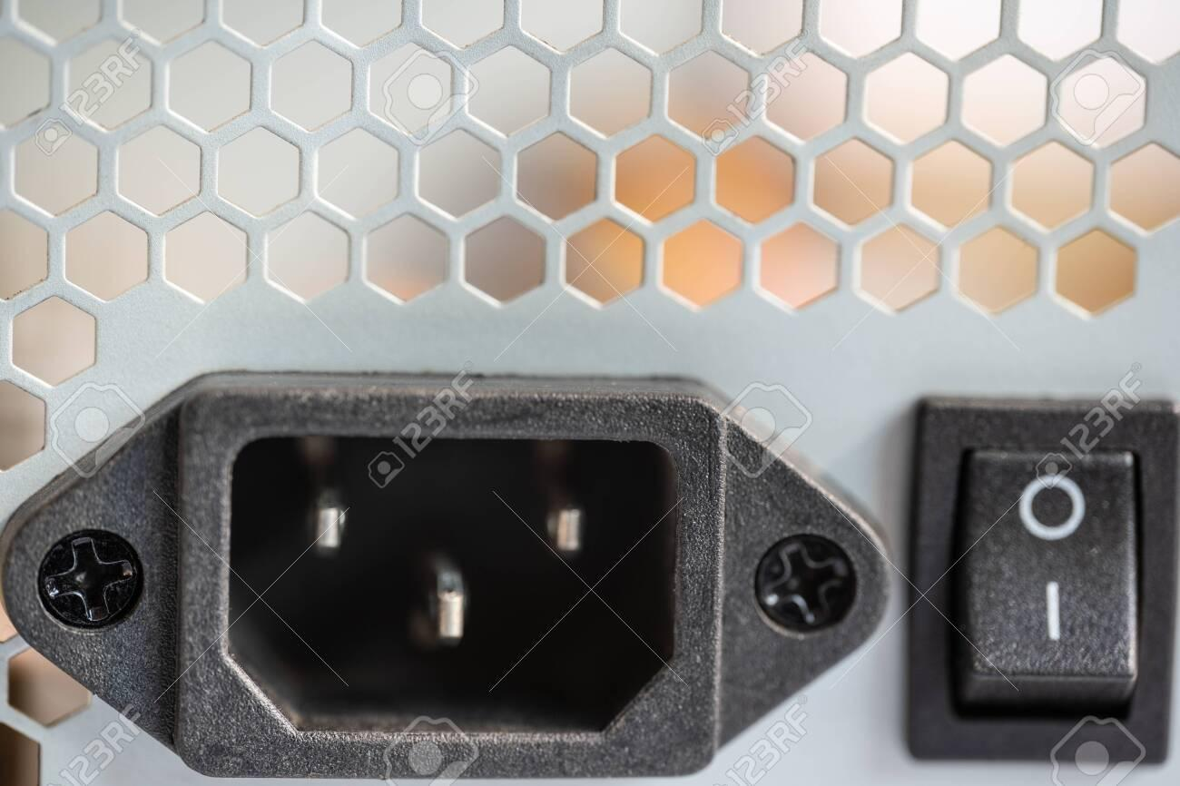
    2. <https://cdn.manomano.com/files/pdf/11542973.pdf>
11. Legs (5 in) [Brenden, done]
12. Wick Inserting Mechanism [Edgar] (collet)
13. Wick Feeding Mechanism [Edgar]
14. Wick Stabilizing Mechanism [Edgar]
15. Wax detector (using light emitting diode and light sensor)
16. Chamber for scents and color additives
17. Mechanism to feed additives to main wax

Notes on Collet:

Uses a bottom cone, when squeezed to smaller cone state, tightens on held item.

<https://www.amazon.com/100pcs-Wooden-Candle-Naturally-Smokeless/dp/B07R1RYYR7?th=1>

Standard wooden wicks have a width of 0.5 inches, unknown (0.04 in) but negligible thickness, height of 5.1 inches.

Outside Models:

Arduino Nano, which acts as our temperature control for the coil and piston control for our actuator.

<https://grabcad.com/library/arduino-nano-clone-with-usb-c-1>